Three-Step Setup for WiFi Access
Since authentication integration for campus wireless internet has been completed, and in view of providing better campus wireless network service, NTHU faculty, staff, and students who have a Campus Wireless LAN Account can enjoy the convenience of wireless internet in three steps.

Step 1：Check the Wireless Network Coverage
Before connecting, you should check whether the wireless network is available in your area. Check with the following methods:
- Campus Wireless LAN Account Service Scope
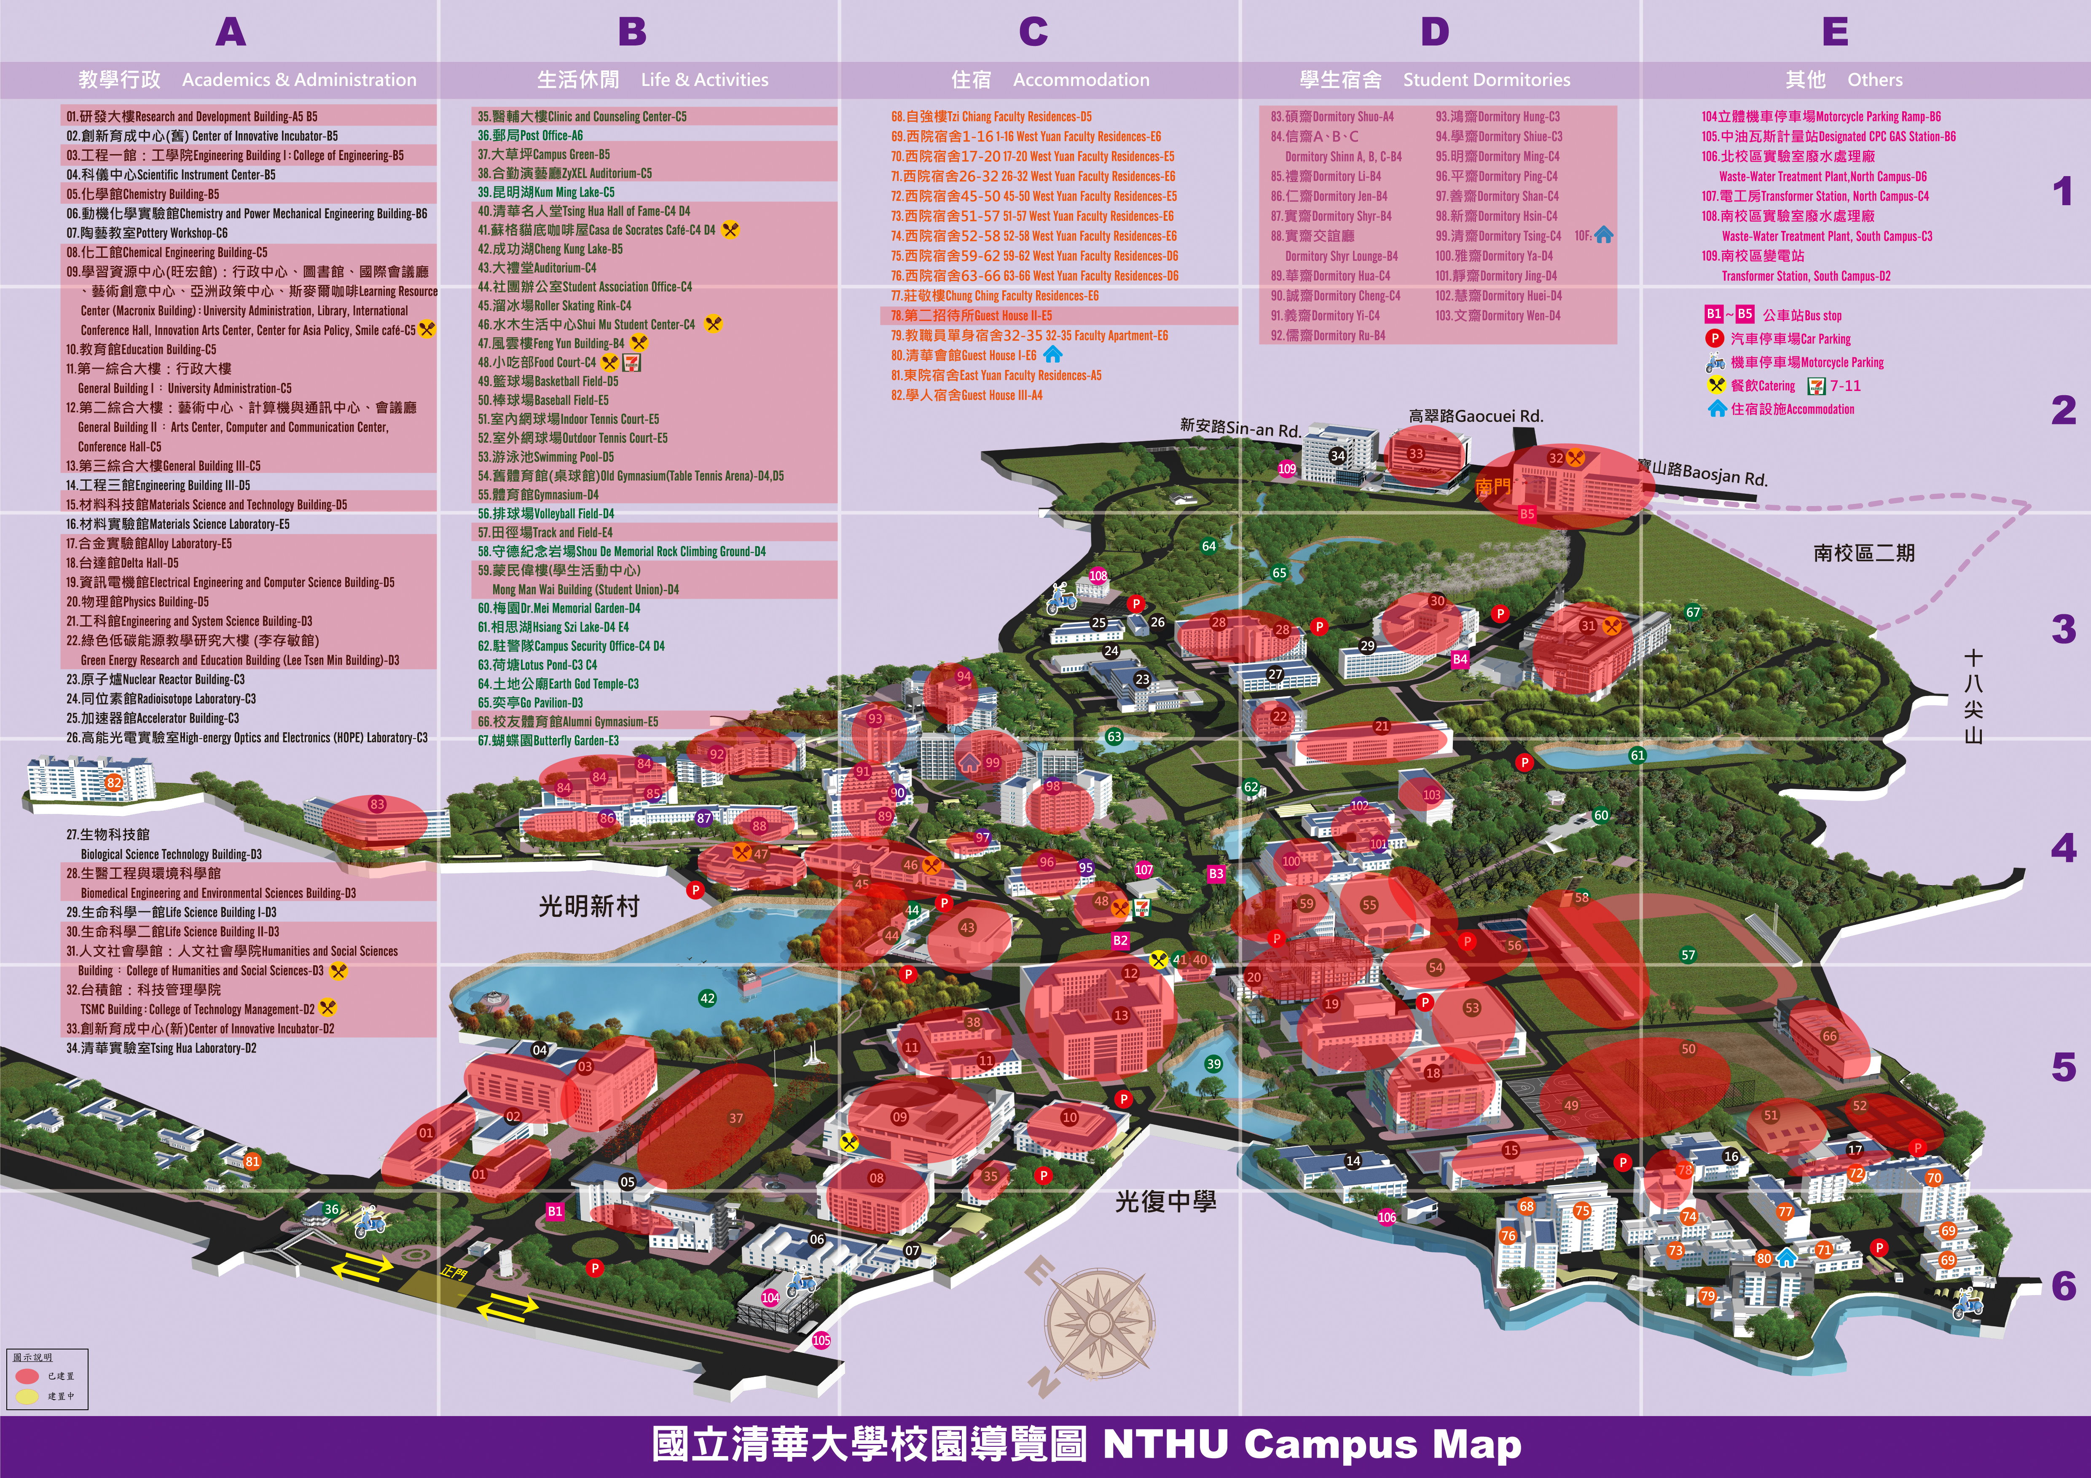Campus Wireless LAN Account Service Scope
- Areas on campus where the Wireless Internet Label is visible (see below)
Wireless Internet Label
- Directly scan for a wireless network signal with a mobile device that supports wireless connections (such as a laptop). If an SSID with the naming scheme “nthu-department-option” is detected (as an example, see Step 2：selecting a reliable wireless access point), this means that there is wireless internet available in your area.

Step 2：Selecting a reliable wireless access point
When connecting, select a verified wireless network name on campus. In other words, whose SSID begins with “nthu-” and which differs by authentication method. See the explanation below:
Management Unit | Service Scope | Web-based authentication SSID  (nthu-department-option) | 802.1X + PEAP Authenticating SSID
Computer & Communication Center | Public areas &  Student Dormitory Public Area: Lounge and Athenaeum) | nthu-cc, TANetRoaming | nthupeap, eduroam
Computer & Communication Center - Nanda Campus | Nanda Campus | nthu-ndcc, TANetRoaming | nthupeap, eduroam
Library | Library | nthu-library | nthupeap, eduroam
Department of Physics | Physics Building | nthu-phys | －
Institute of Statistics | General Building III 8F | － | nthupeap, eduroam
Department of Mathematics | General Building III B1-7F | nthu-math | nthupeap, eduroam
Department of Chemistry | Chemistry Building 1F | nthu-chem | －
Institute of Computational and Modeling Science | General Building II B side 8F | nthu-cms | nthupeap
Department of Power Mechanical Engineering | Engineering Building I 1-6F | nthu-pme | nthupeap
Department of Industrial Engineering & Engineering Management | Engineering Building I 1F,2F,7-9F | NTHU_IEEM | nthupeap
Department of Chemical Engineering | Chemical Engineering Building B1-3F | nthu-che | nthupeap
Department of Materials Science and Engineering | Materials Science and Technology Building  Delta Building B1F,4F | nthu-mse | nthupeap
Department of Biomedical Engineering and Environmental Sciences | Biomedical Engineering and Environmental Sciences Building | nthu-bmes | －
Department of Engineering and System Science | Engineering and System Science Building | nthu-ess-xxxx | nthupeap
Institute of Nuclear Engineering and Science | Green Energy Research and Education Building (Lee Tsen Min Building) | nthu-nes | nthupeap
College of Humanities & Social Sciences | Humanities and Social Sciences Building | nthu-hss-xx | nthupeap
College of Life Science | Life Science Building II - B1~2F  Brain Research Center(Tsing Hua Laboratory 5F) | NTHU-LIFE  nthu-brc | nthupeap
Department of Electrical Engineering | Electrical Engineering and Computer Science Building  Delta Building - 2F,5F,8-9F | nthu-ee | nthupeap, eduroam
Department of Computer Science | Electrical Engineering and Computer Science Building  Delta Building - 1F,5F-7F  General Building II A side 7F | nthu-cs-xx-x | －
College of Technology Management | TSMC Building | nthu-ctm | nthupeap
Tsing Hua College | Education Building 2F~4F | nthu-thc | nthupeap
Institute of Learning Sciences and Technologies | General Building II B side 4F | nthu-ils | nthupeap
Center of Innovation Incubator | Center of Innovation Incubator | nthu-cii | nthupeap
National Center for Theoretical Sciences | General Building III 4F | nthu-nctsphys | nthupeap, eduroam
Note: “-” means that the unit does not provide such service

Step 3：Enter the Campus Wireless LAN Account
After connecting to a reliable wireless access point, the user must enter login information for their Campus Wireless Network Account or cross-campus roaming account on a designated interface. Once successfully authenticated, you may begin using wireless network services. The interface for entering account information will differ depending on the method of authentication. A detailed description using the campus public-area wireless LAN as an example can be found at Campus Wireless LAN Authentication Method:

