Apply for campus wireless LAN account

1. Login from Academic Information System
- Connect to https://www.ccxp.nthu.edu.tw/ccxp/INQUIRE/index.php?lang=english
- Enter your AIS password.
  - If you forgot your AIS password, please click “Forgot your password?” below “login” on the page of AIS system for help.
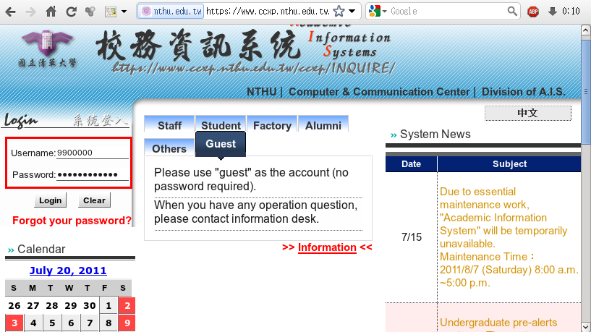
- Select “Computer and Communication Center Services” first, and then “Division of Network Systems”.
- Click the URL “Division of Network Systems” on the right frame, and then your browser will be redirected to the service portal of Division of Network Systems
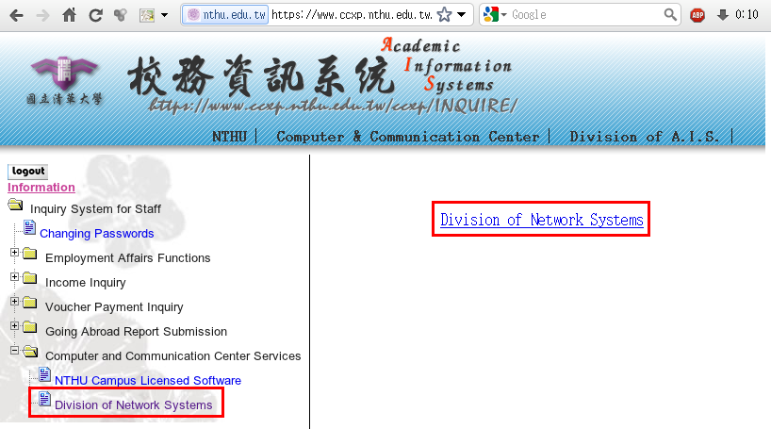

Failed to redirect to the service portal
- If the error message like “cannot get checksum or expired…” appears, it means that the URL is expired due to over the valid period of 2 minutes after its generation. Please click the “Division of Network Systems” on the left menu (or login AIS again) to generate another valid URL.
- If the error message like “IP mismatch…” appears, it means that your IP address connecting to the portal differs from that to the AIS. Please keep your IP address always the same while performing manipulation.

Succeed in redirecting to the service portal
- If like the below window shows, it means that you successfully connect to the service portal of Division of Network Systems (the URL is like https://ua.net.nthu.edu.tw/portal/...)
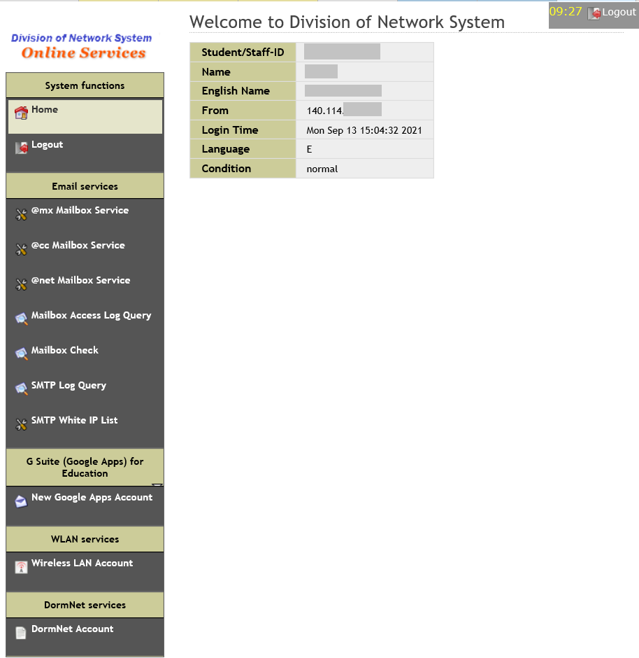

2. Apply for a wireless account

step 1 Welcome to Network Systems Division
- Click “Wireless LAN Account” (NTHU IP only)
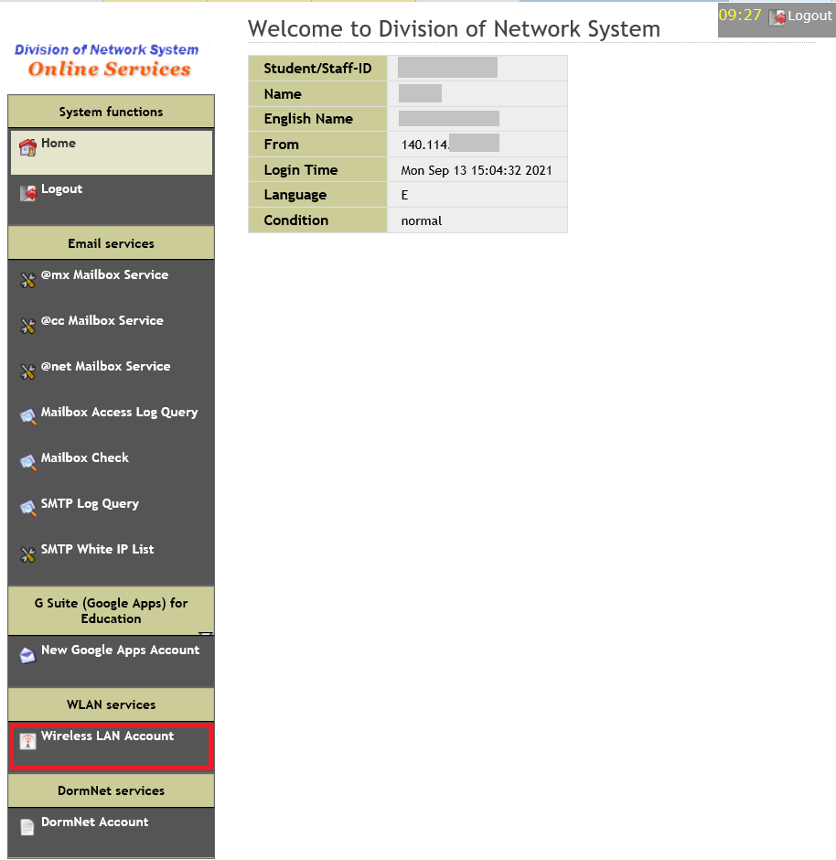

step 2 Campus Wireless LAN Account Application and Change
- Input/Check Email
- Input/Check Phone
- Input “Choose a password”
- Input “Re-enter password”
- Read “Network Usage Policy”
- Read “Using Campus Wireless LAN”
- Click “Accept”
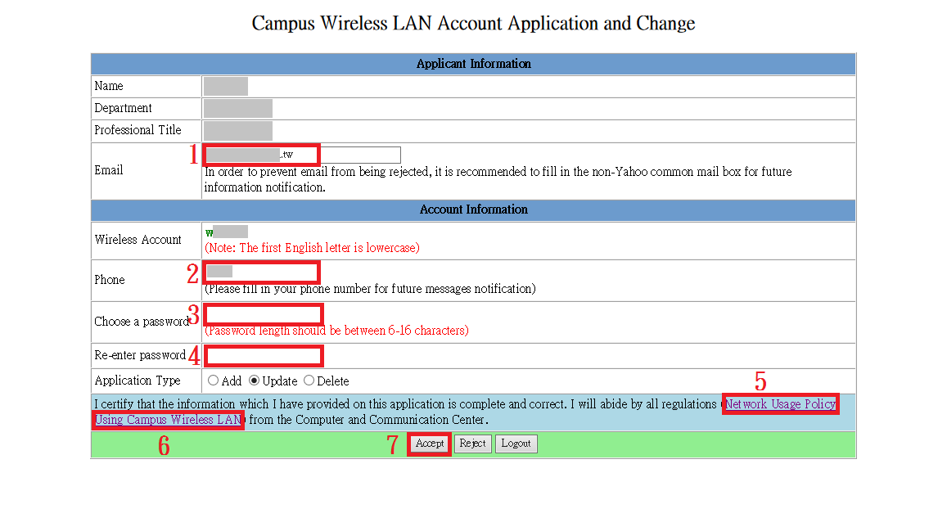

step 3 Campus Wireless LAN Account Application and Change
- Your account will be activated within 10 minutes.


