Instruction for installation of web editor software
To avoid being illegal, you are reminded to notice the relevant laws of copyright when creating your webpage.
- The filename of homepage is index.html
- The free open-source web editor software Nvu is recommended. It is suitable for beginners as it turns many HTML commands into buttons.Nvu Dowanload site
- Only one free software is provided for your use here. You can also use other software and upload the edited page to the FTP Site.

Step 1
- Run the nvu-1.0-win32-installer-full to start the installation.
- Click on “next”.
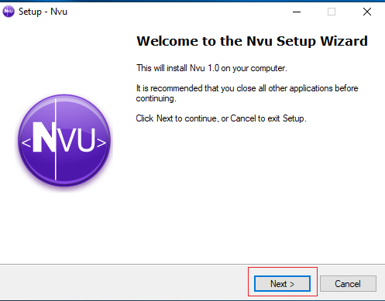

Step 2
- Choose “I acceptt the agreement”.
- click on “Next”.
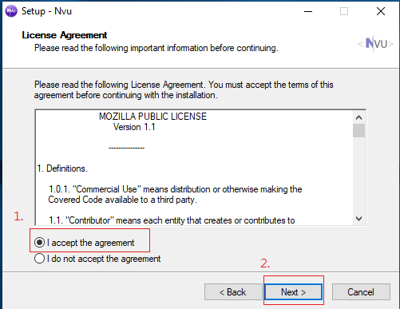

Step 3
- Click on “Next”
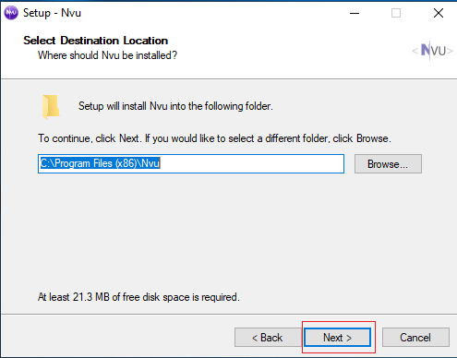

Step 4
- Click on ”Next”
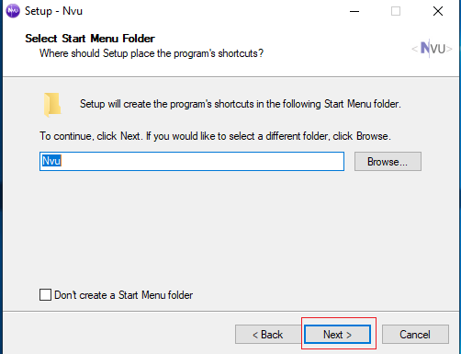

Step 5
- Select “Create a desktop icon” and “Create a Quick Launch icon”.
- Click on “Next”.
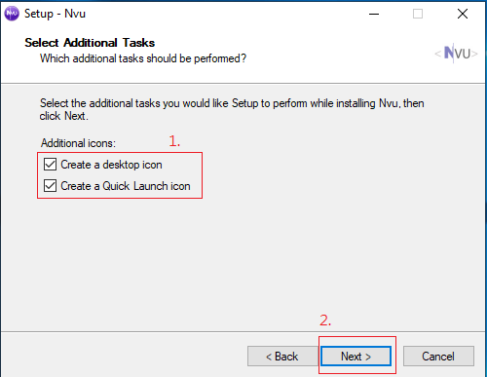

Step 6
- Click on “Install”.
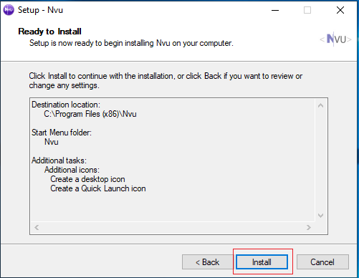
—-

Step 7
- Click on “Finish”.
- After completing the installation, you can edit your homepage.


