Reset your email password
For a NTHU user (including students, faculty, and staff), you have the following two ways to reset your email password:
- Via Academic Information Systems (AIS), you can reset it without using your old email password. (Recommendation)
- By using your old email password, you can reset a new password.

I. Via Academic Information Systems

1. Login AIS
- Connect to https://www.ccxp.nthu.edu.tw/ccxp/INQUIRE/index.php?lang=english
- Enter your AIS password.
  - If you forgot your AIS password, please click “Forgot your password?” below “login” on the page of AIS system for help.
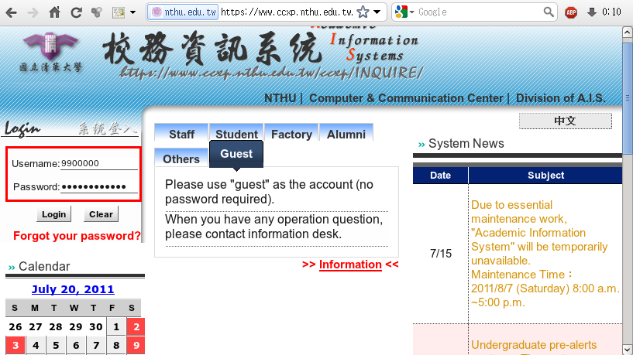
- Select “Computer and Communication Center Services” first, and then “Division of Network Systems”.
- Click the URL “Division of Network Systems” on the right frame, and then your browser will be redirected to the service portal of Division of Network Systems
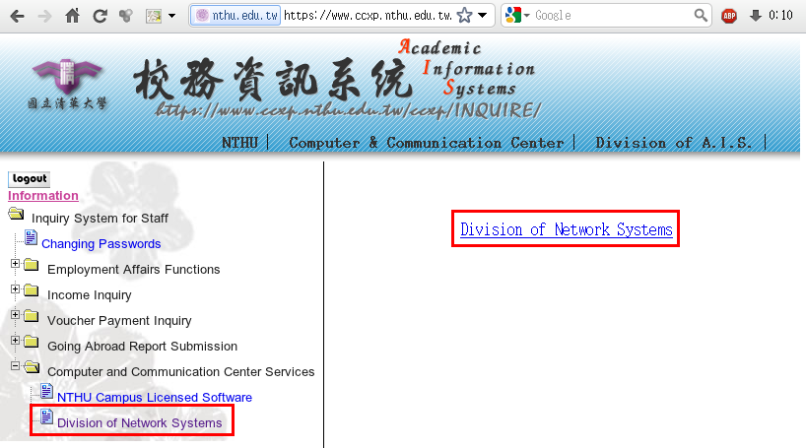

Failed to redirect to the service portal
- If the error message like “cannot get checksum or expired…” appears, it means that the URL is expired due to over the valid period of 2 minutes after its generation. Please click the “Division of Network Systems” on the left menu (or login AIS again) to generate another valid URL.
- If the error message like “IP mismatch…” appears, it means that your IP address connecting to the portal differs from that to the AIS. Please keep your IP address always the same while performing manipulation.

Succeed in redirecting to the service portal
- If like the below window shows, it means that you successfully connect to the service portal of Division of Network Systems (the URL is like https://ua.net.nthu.edu.tw/portal/...)
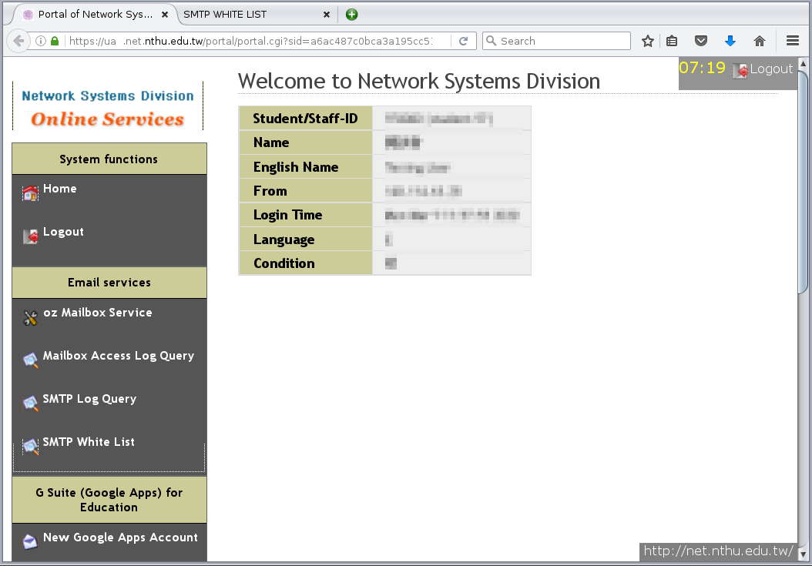

2. Reset your email password
- Select “Mailbox Service” according to which kind of mailbox you own, and then “Set the password for …”
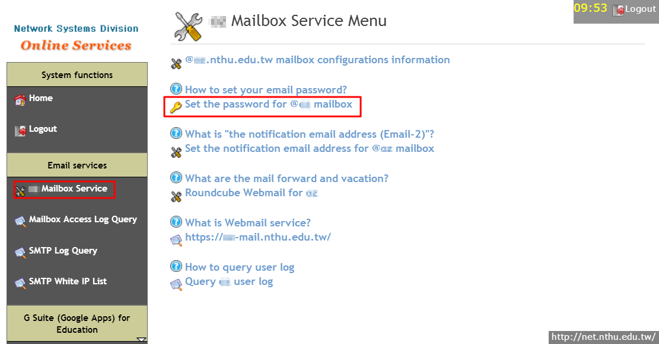
- Check your account and data, and then enter your new password on the two fields of “New Password” and “Confirm.”
  - Too short or too weak passwords are not allowed!
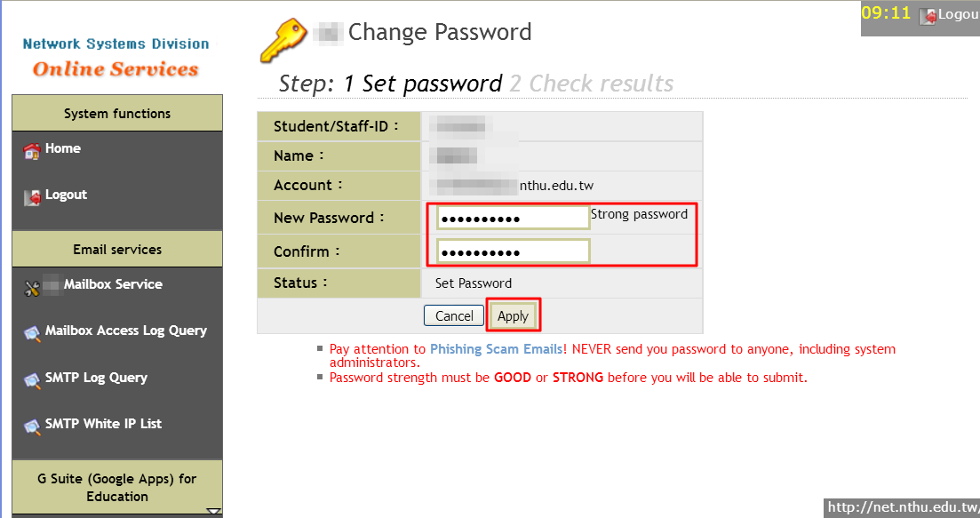
  - The new password will work in about 10 minutes and a notification mail will be sent to you.
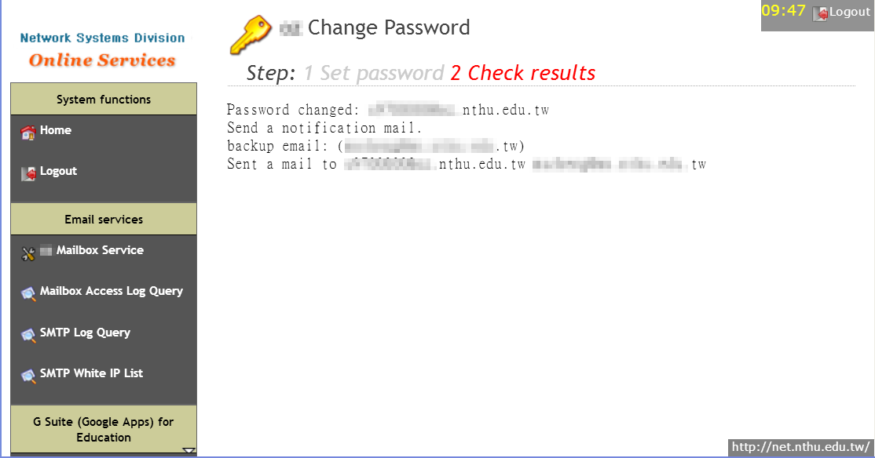

II. By using your old email password

1. Log on the portal with your mailbox password
- Connect to https://ua.net.nthu.edu.tw/portal/login.cgi?lang=en_US
- Enter your “Email account,” “Password,” and the “Verification code,” and then click “Login.”
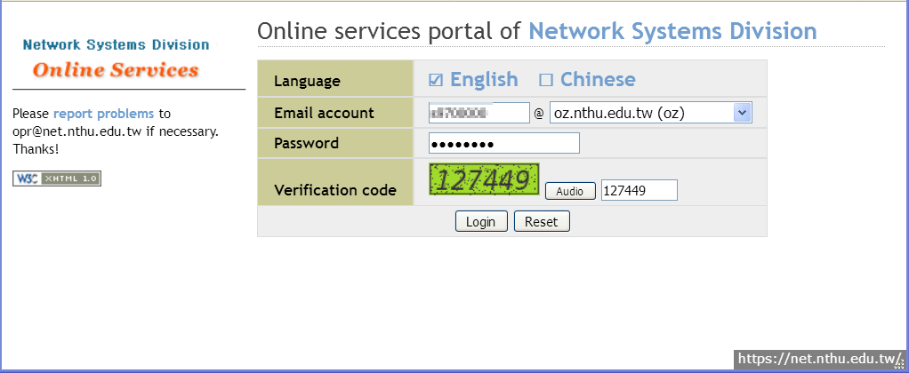

2. Reset your email password
- Select “Mailbox Service” according to which kind of mailbox you own, and then “Set the password for …”
- Check your account and data, and then enter your new password on the two fields of “New Password” and “Confirm.”
  - Too short or too weak passwords are not allowed!
  - The new password will work in about 10 minutes and a notification mail will be sent to you.

