Procedure of Information and Communication Security Report
- The Network Systems Division of the Computer and Communication Center serves as the contact point for reports of cyber attacks on the campus network and for reporting such attacks to the external authorities.
- The smallest units of the information and communication reporting system are the department network managers.
- After receiving reports on internal security incidents, the Network Systems Division will dispatch staff to assist in confirmation of the incidents and provide relevant suggestions for system recovery; they will simultaneously report the incidents to the National Information and Communication Security Taskforce and seek external assistance when necessary.
- Acceptable means of reporting include telephone and email.

Process for Information and Communication Security Report
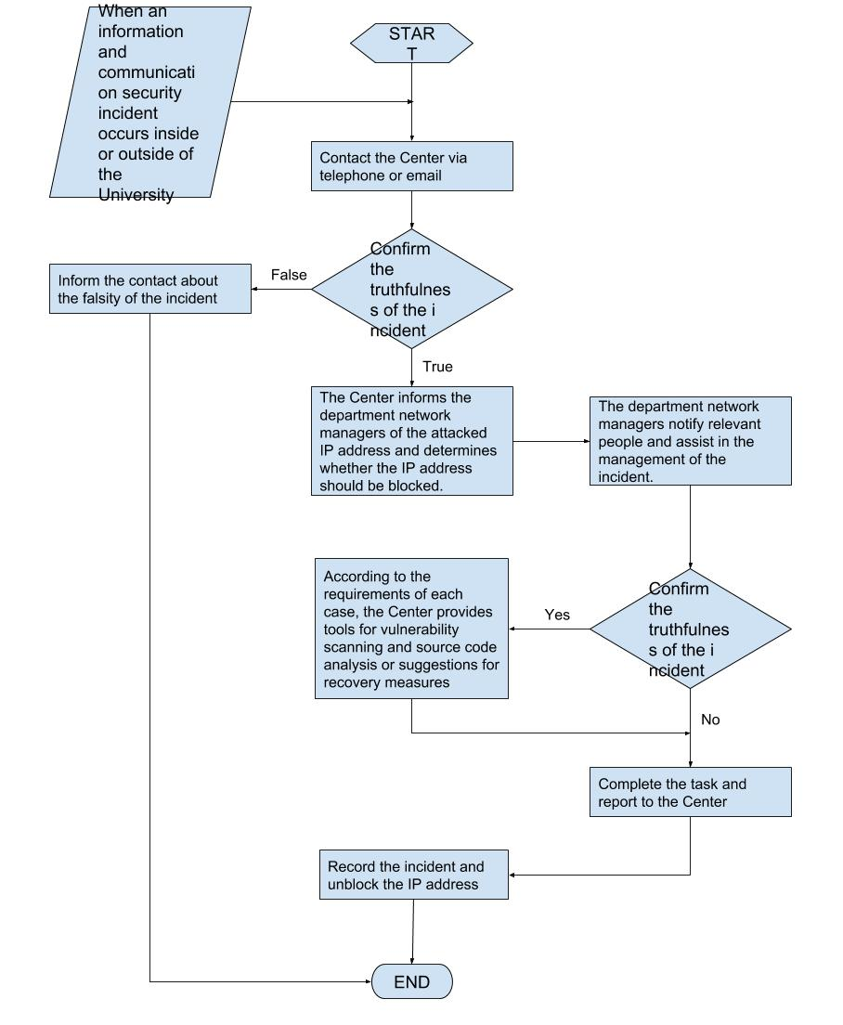Information and Communication Security SOP

