Instruction for uploading files

Step 1
- After getting connected via FileZilla, Select a folder in the local site.
- Select the file you want to upload in the local site.
- Drag the selected file to the remote site.
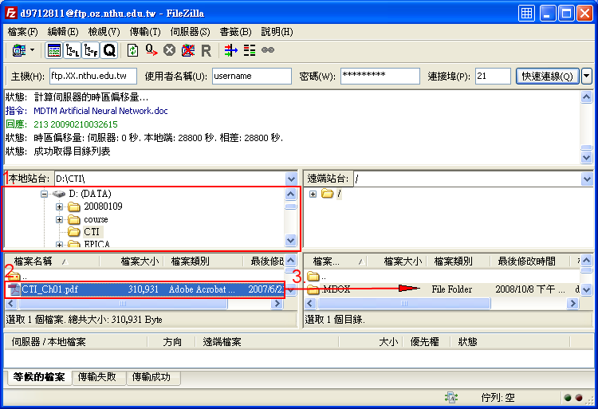

Instruction for downloading files

Step 1
- Select the file you want to download in the remote site.
- Then drag it to the local site.


