Installation instructions for FTP software
- The full name of FTP is File Transfer Protocol, a protocol mainly for file transfer. FTP is among the most used items among academic internet resources.
- You are recommended to use the free software of FTP: FileZilla3.2.0 Official website downloading page

Step 1
- select the “install.exe” and run it

Step 2
- After reading the License Agreement, select “I Agree” to go to the next step. You can also select “Cancel” to cancel the installation as shown below.
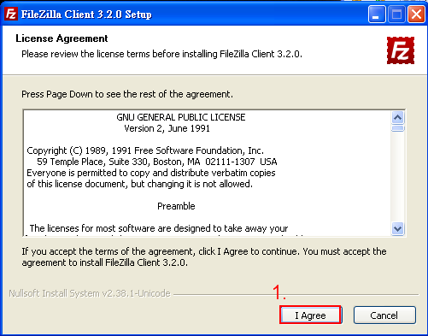

Step 3
- If your computer is only for personal use, select “next” to go to the next step. If it is shared by multiple persons, you should select “Only for me.”
- If you complete the above selection, please click on “Next>” to continue as shown below.
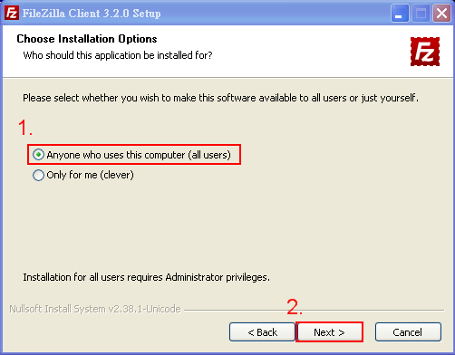

Step 4
- You can simply choose Default Installation. Please click on “next” to continue as shown below.
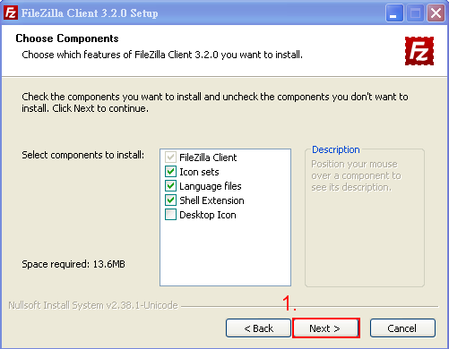

Step 5
- Select “Browse” to select the folder you would like to install it in. You can simply choose to use the default setting.
- After selecting the installation location, click ”Next>” to continue as shown below.
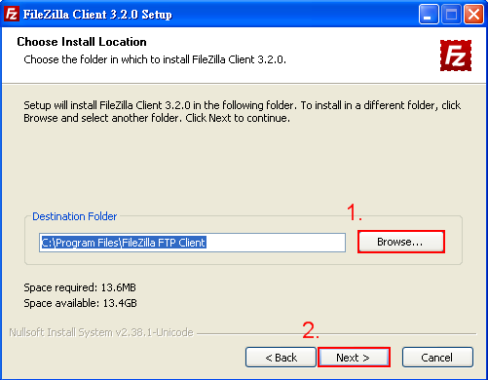

Step 6
- Select “Start Menu Folder”, then click on “install” as shown below.
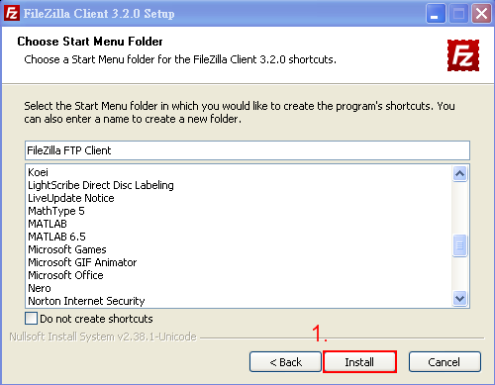

Step 7
- Complete the installation, click on “Finish”. Then start using FileZilla as shown below.


