Instruction for changing the permission and attributes of files

Step 1
- After getting connected via FileZilla, right click on the file you want to change its access permission.
- Select “the permission of file”.
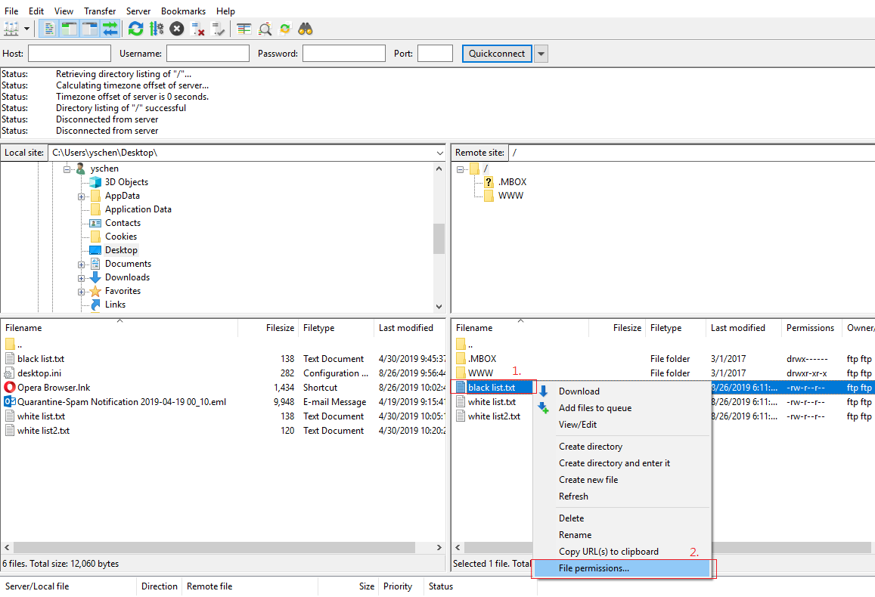

Step 2
- Click on the access permission you need, determine the permissions of file owner, group and public.
- To change the attribute of the file, change the value. You can also select the directory to change all the attributes of files.
- Click on “OK” to finish the setting.


