How to prevent open DNS resolver by setting up Symantec Firewall？
We can prevent PC running open DNS resolver by changing firewall setting. We’ll take Symantec as an example, please follow these step.
- Turn on Symantec Endpoint Protection, click Network threat Protection, and then select configure firewall rules
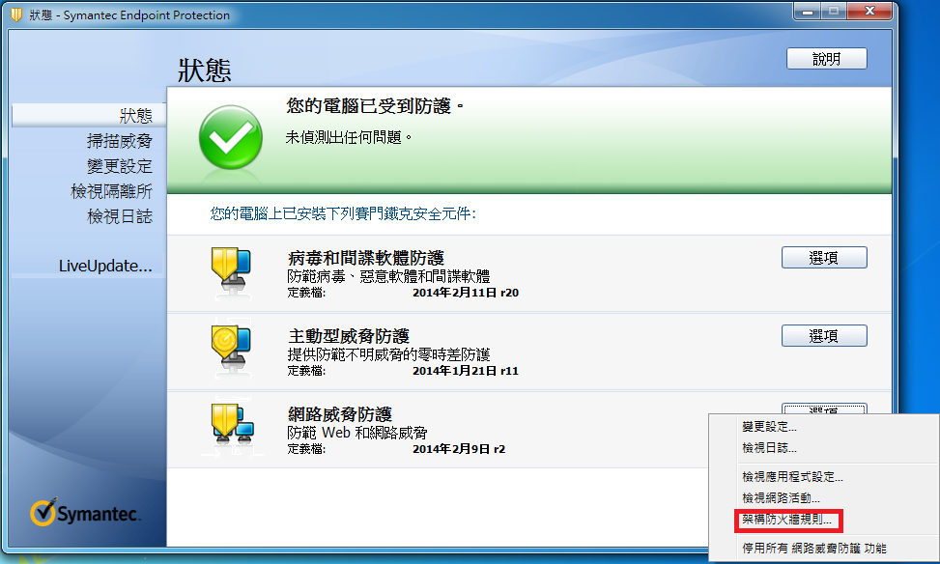
- In configure firewall rules dialog box , click Add
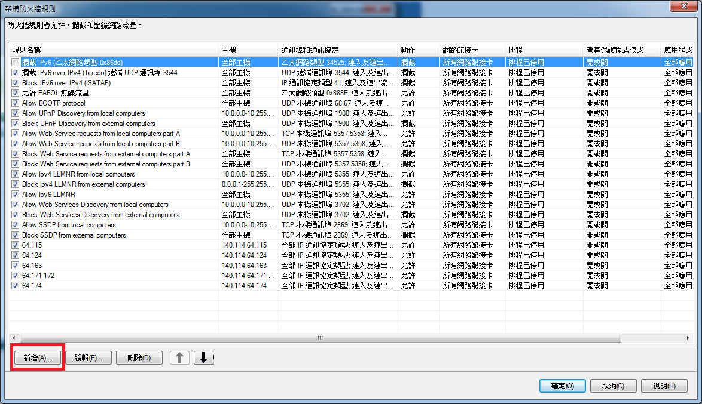
- In Add Firewall Rule
- Give the rule name and type in text box, for example: DNS_resolver
- Select Block this traffic
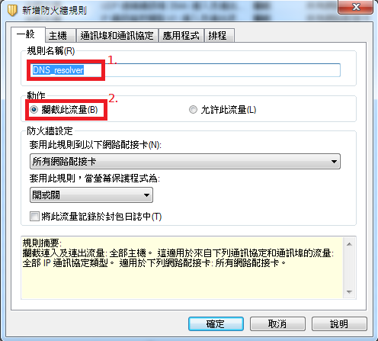
- Click the tab for Ports and Protocols
- choose UDP from dropdown for Protocol
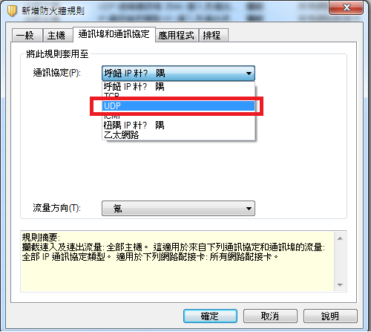
- Type 53 In the Local Ports field
- Choose Incoming in dropdown for Traffic direction
- Click OK
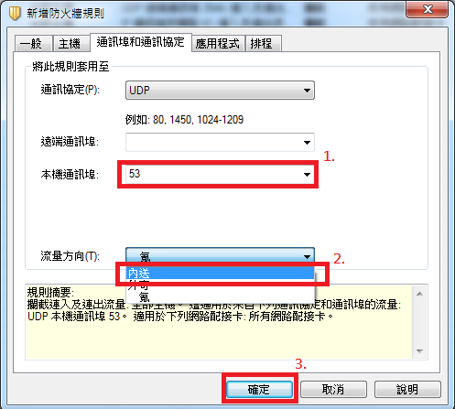
- Check that “DNS_resolver” has shown in configure firewall rules dialog box
- Click OK


