How Do I Activate or Deactivate the Spam Filter?
Through the anti-spam service provided by the Center, the user can decide whether or not to activate spam filtering through the mail reporter (activated by default). If deactivated, all mails will be accepted, except those on the blacklist.
- If you select “By pass anti-spam” no spam mail will be filtered. Please do not report missed spam to the vendor to avoid unnecessary trouble. Thank you!

Activating or Deactivating the Spam Filter
- Log in to Mail Reporter.。
- Click “Mail Account” in the left column.
- Check “Policy” on the right side of the screen。
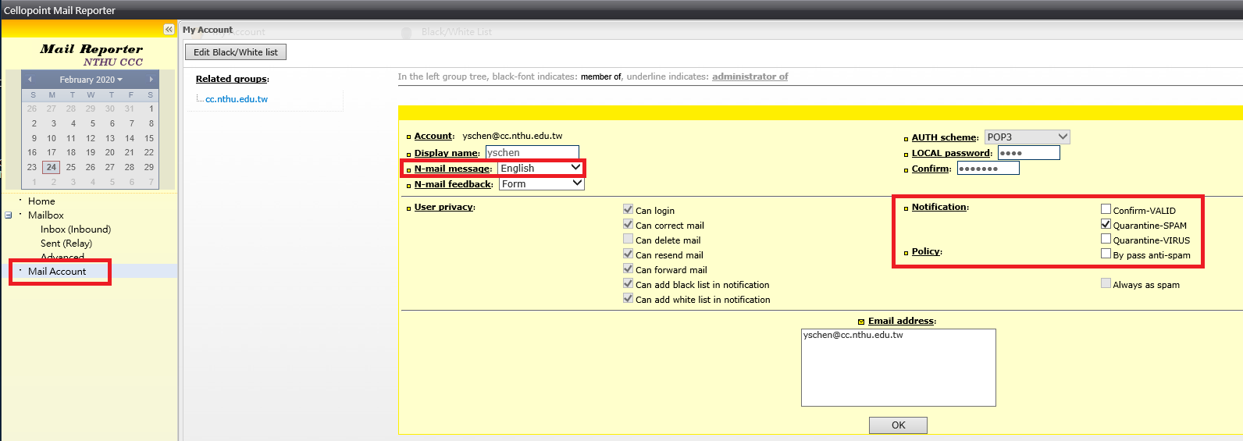
- If you do not wish to activate the spam filtering function, check the box for “By pass anti-spam”; if you wish to activate it, then uncheck that box.
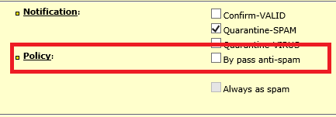
- Click “OK” at the bottom to complete configuration.

