How to set up network TCP/IP
Description：
The following setting examples are mainly based on Apple macOS Sequoia 15.x. For macOS Monterey 12.x users, please checkHERE
Windows 11 users check HERE
Windows 8/10 users check HERE.
WiFi Router users check HERE

Step1
- In the upper left corner of the screen, click “Apple”, then click “System Settings”, as shown below: ：
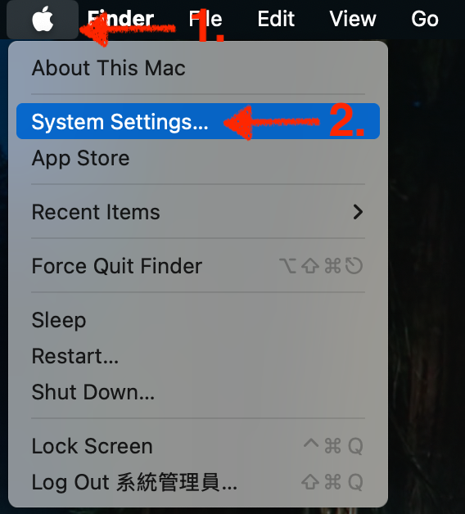

Step2
- Click “Network” and then click “Ethernet”. It varies depending on the Apple computer model. In addition to Ethernet, it may also be USB 10/100/1000 Ethernet, Thunderbolt Ethernet or others. The settings are the same depending on the model. As shown below:
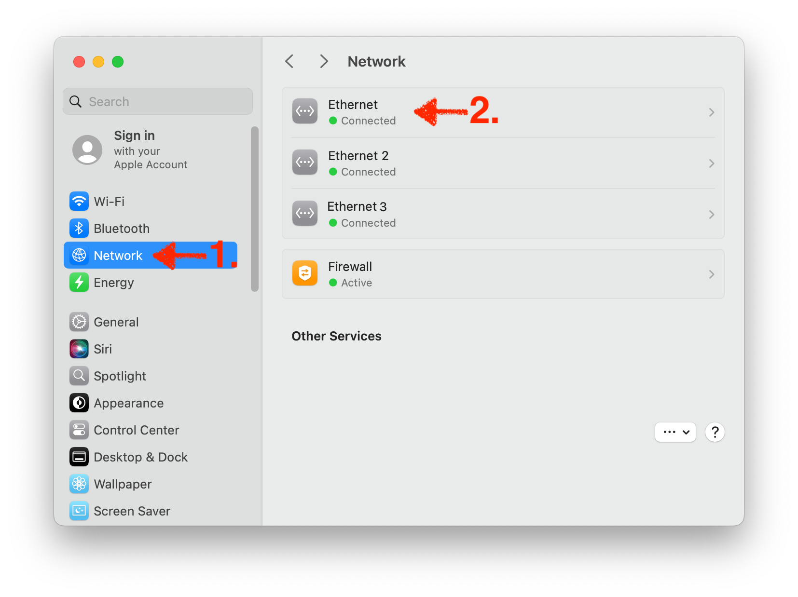

Step3
- Click “Details…”. As shown below:
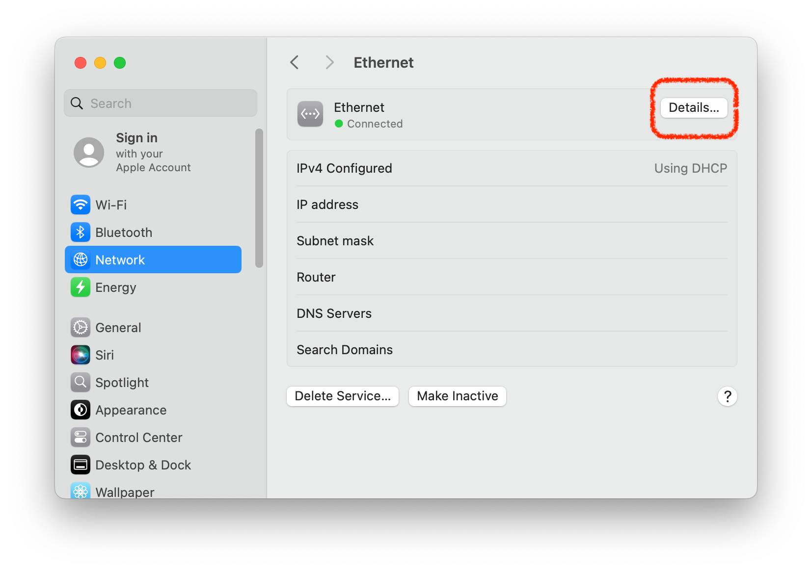

Step4
- 4-1: click “TCP/IP” on the left
- 4-2: set IPv4: Manually
- 4-3: After Dormitory Network Application Process, the given IP address, subnet mask, and preset gateway (equivalent to router) are filled in in sequence, as shown below:
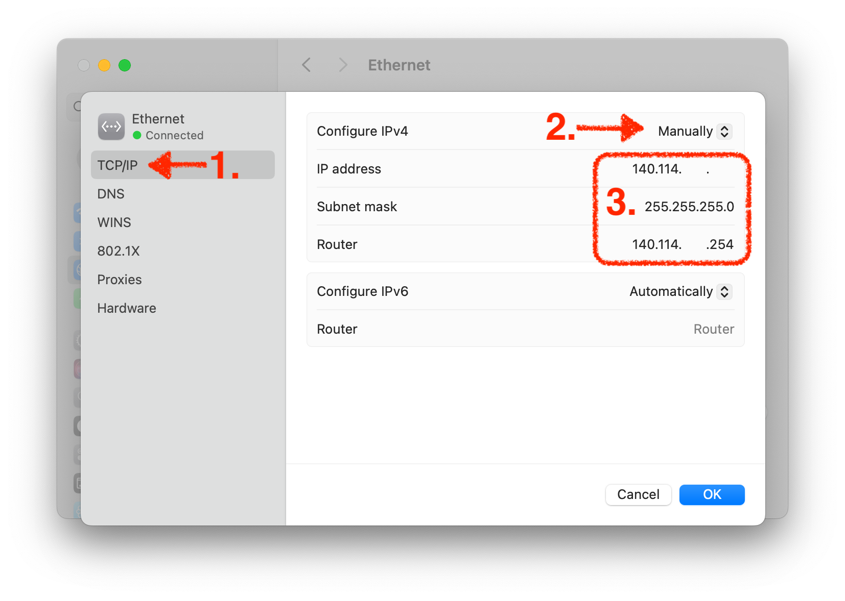
- 4-4: click “DNS” on the left
- 4-5: click “+”
- 4-6: enter “140.114.64.1” and “140.114.63.1”
- 4-7: click “OK”, as shown below:
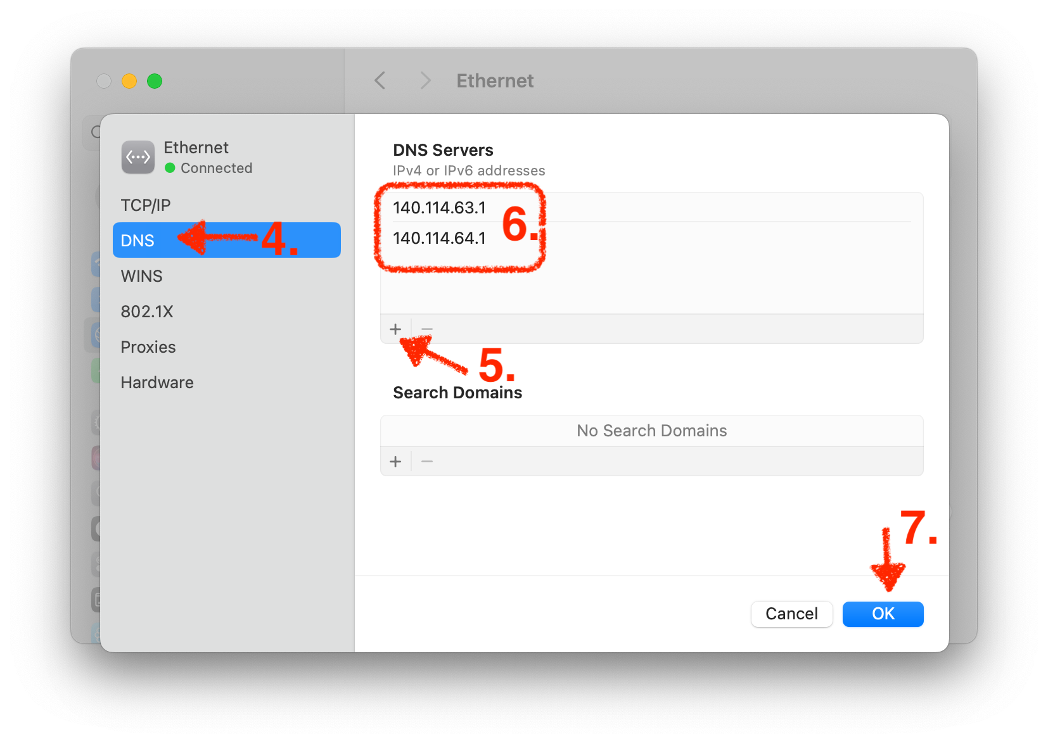

Step5
- The TCP/IP setting is completed. Try to see if you can access the Internet!
- FAQ：How to Speed Test between my Dorm Network and campus backbone？
- FAQ：What should I do If My Dorm Net Suddenly Offline？

服務信箱：dorms@cc.nthu.edu.tw
服務電話：分機31178（學生宿舍網路服務專線)
服務時間：週一至週五 08:30-12:00 13:30-17:00
計算機與通訊中心
網路系統組 敬啟

