Network config - TCP/IP settings
Description:
The following example is based on Microsoft Windows 8/10 Enterprise(In-campus Authorized Software)!
Windows 11 users check HERE.
macOS Sequoia 15.x users check HERE.
WiFi Router users check HERE.

Step1
- Click on the network icon in the lower right corner of the screen, then click the “Network & Internet settings”.
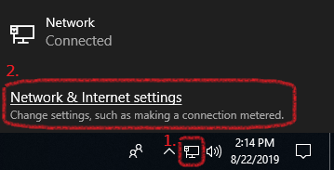

Step2
- Click “Change adapter options”.
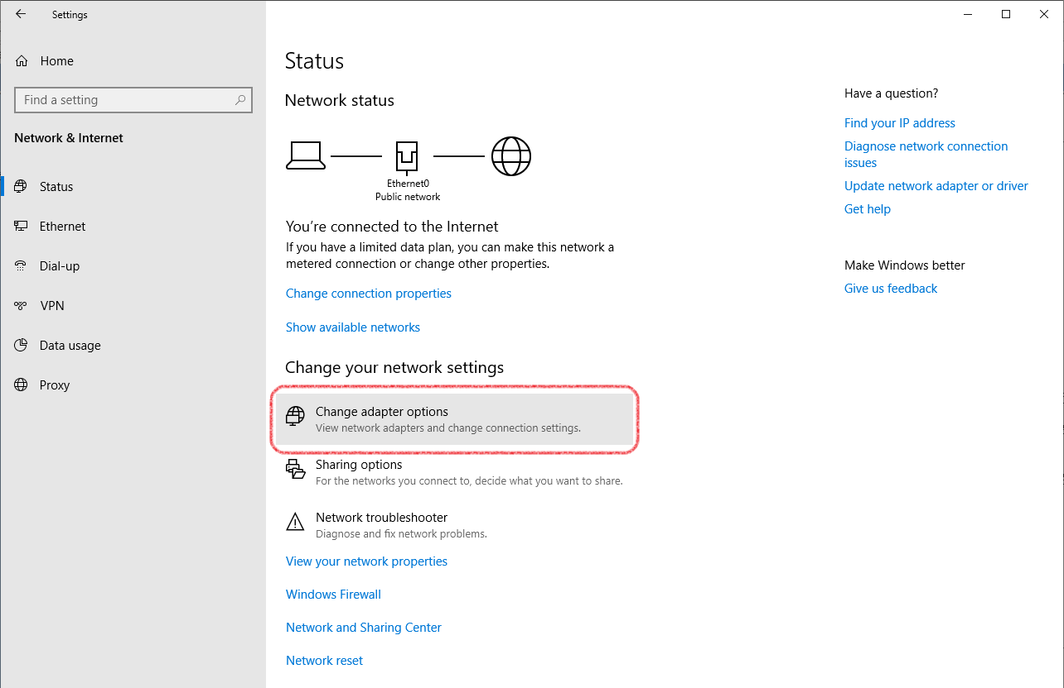

Step3
- Right click on “Ethernet”, then click “Properties”.
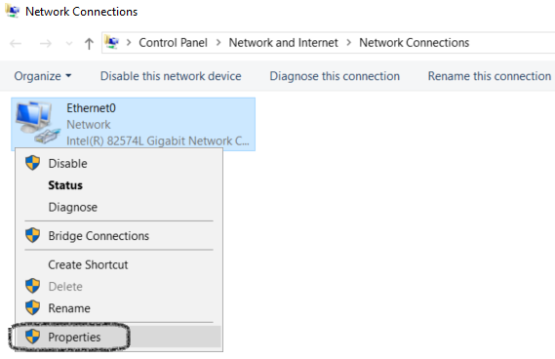

Step4
- Find and select “Internet Protocol Version 4 (TCP/IPv4)”, then click “Properties”.
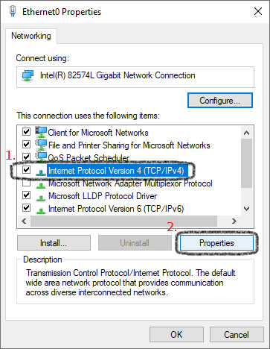

Step5
- Fill in your Dormitory Network TCP/IP settings and don't forget to click “OK”.
- Subnet mask is 255.255.255.0, do not input 255.255.0.0!
Although you can freely open any website you like, except the NTHU related page(140.114.*.*).
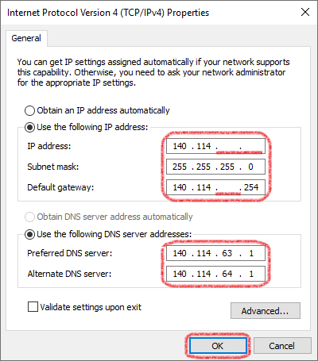

Step6
- Network config completed, feel free to connect the Internet.

