Procedures for applying the NTHU student Dormnet account
- Login AIS. Connect to https://www.ccxp.nthu.edu.tw/ccxp/INQUIRE/index.php?lang=english
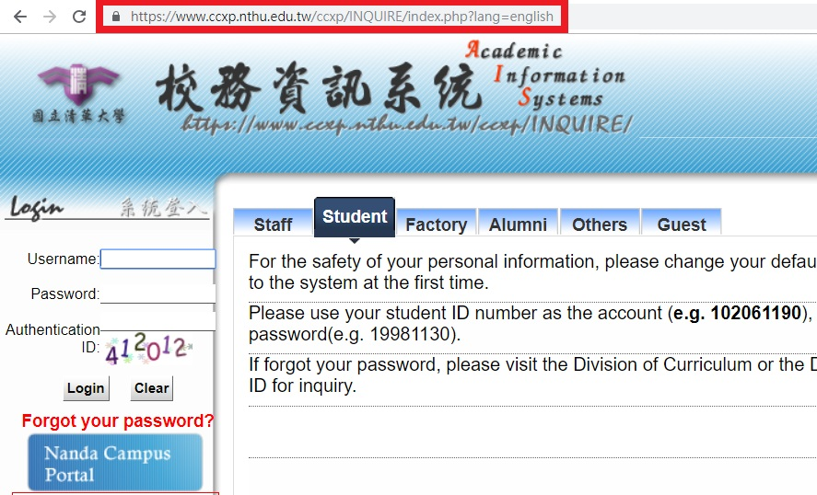
- Enter your AIS password.
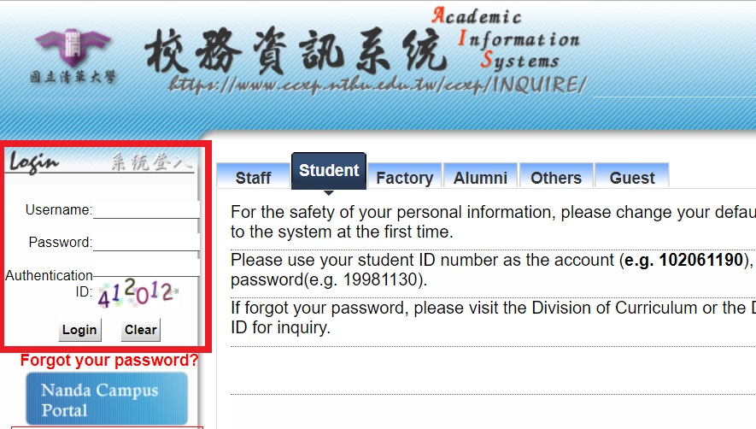|}}
- Click “Division of Network Systems”
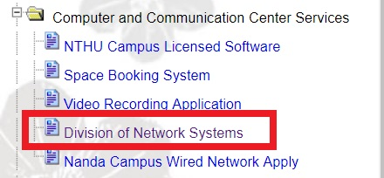
- Click right side “Division of Network Systems”
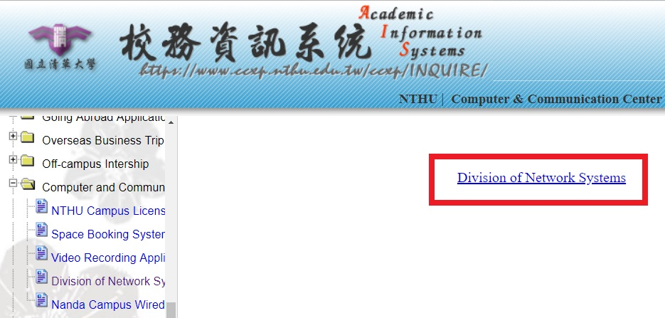
- Click bottom “Dormnet Account” (NTHU IP Only)
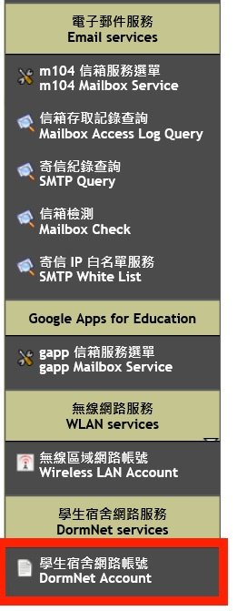
- Click “Network Usage Policy” and “Regulations for Using DormNet” first. Set the password and Accept.
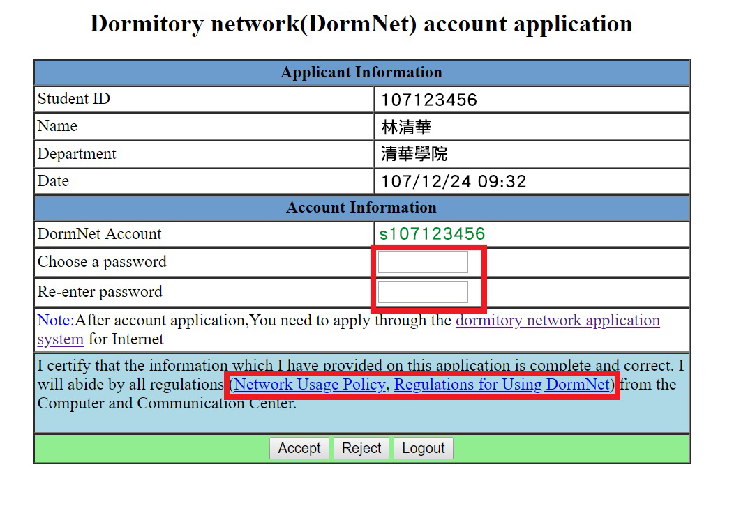
- After applying the NTHU student Dormnet account, procedures for apply DormNet.

