Apply for NTHU student email account
A NTHU student can apply for her/his NTHU student email account via Academic Information Systems (AIS). The procedures list below:

1. Login from Academic Information System
- Connect to https://www.ccxp.nthu.edu.tw/ccxp/INQUIRE/index.php?lang=english
- Enter your AIS password.
  - If you forgot your AIS password, please click “Forgot your password?” below “login” on the page of AIS system for help.
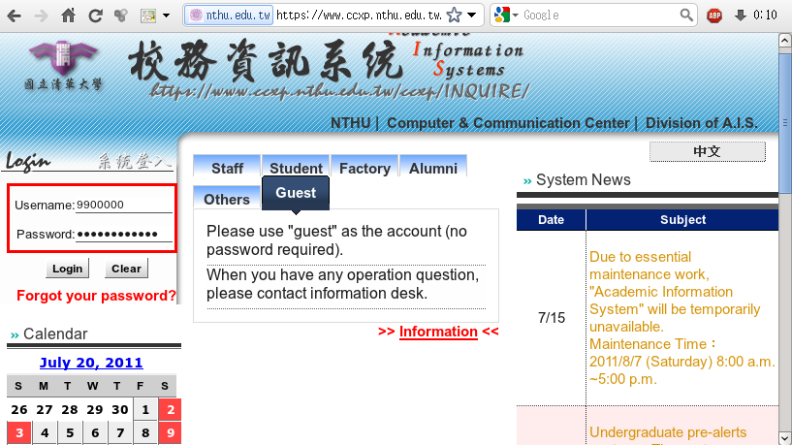
- Select “Computer and Communication Center Services” first, and then “Division of Network Systems”.
- Click the URL “Division of Network Systems” on the right frame, and then your browser will be redirected to the service portal of Division of Network Systems
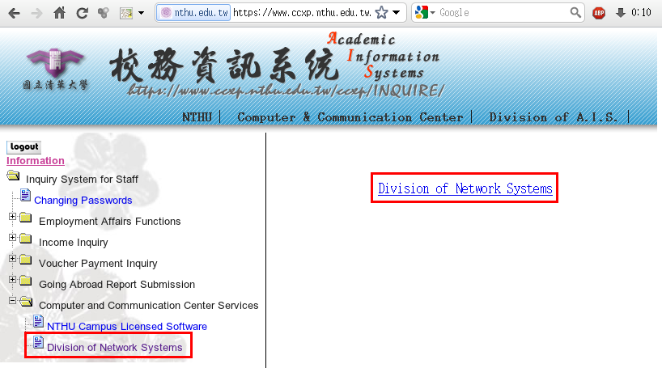

Failed to redirect to the service portal
- If the error message like “cannot get checksum or expired…” appears, it means that the URL is expired due to over the valid period of 2 minutes after its generation. Please click the “Division of Network Systems” on the left menu (or login AIS again) to generate another valid URL.
- If the error message like “IP mismatch…” appears, it means that your IP address connecting to the portal differs from that to the AIS. Please keep your IP address always the same while performing manipulation.

Succeed in redirecting to the service portal
- If like the below window shows, it means that you successfully connect to the service portal of Division of Network Systems (the URL is like https://ua.net.nthu.edu.tw/portal/...)
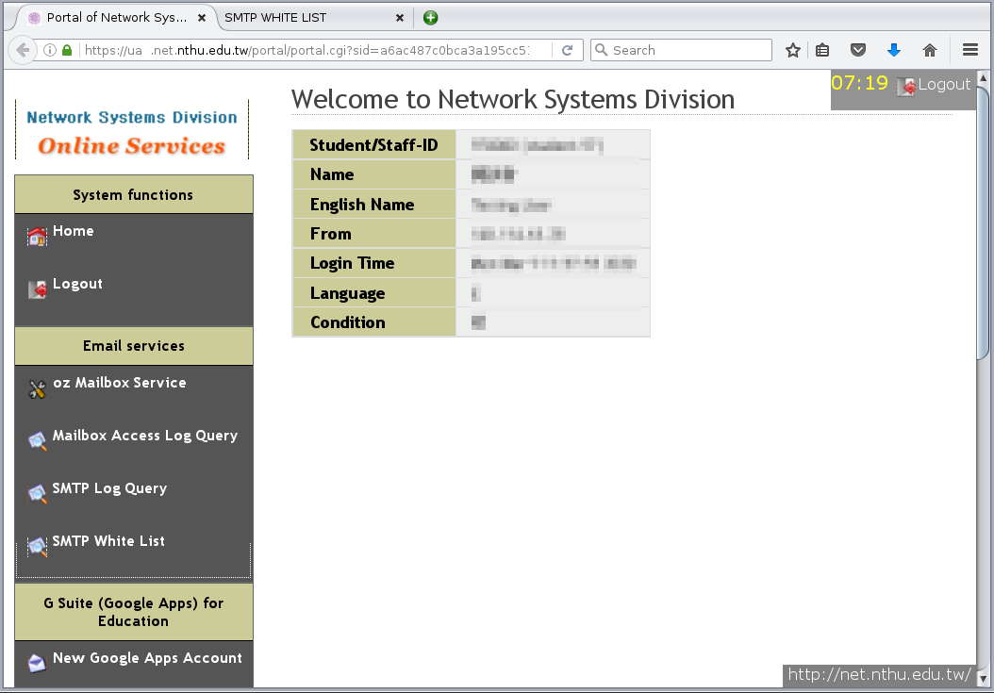

2. Apply for an email account
- On the service portal of Division of Network Systems, click “New Email Account” of the left menu.
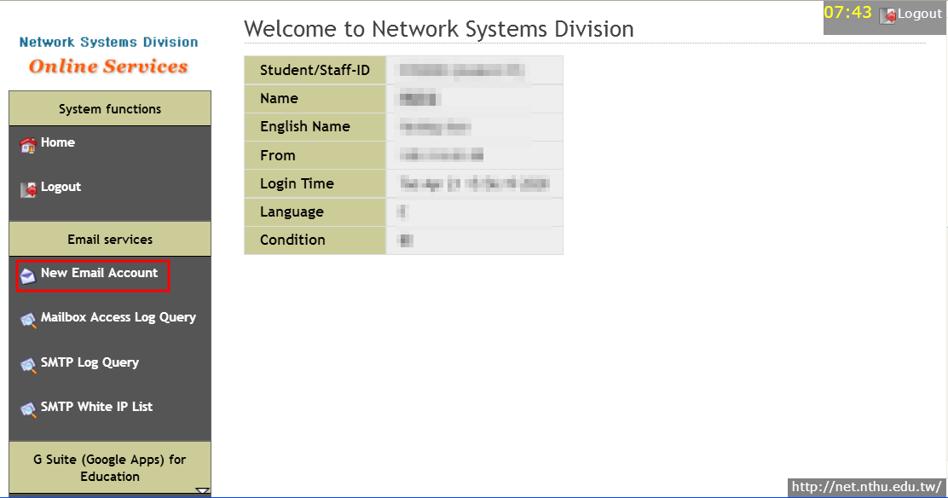
- Read 「Network Usage Policy」 first, and then click option “Accept and Continue.”
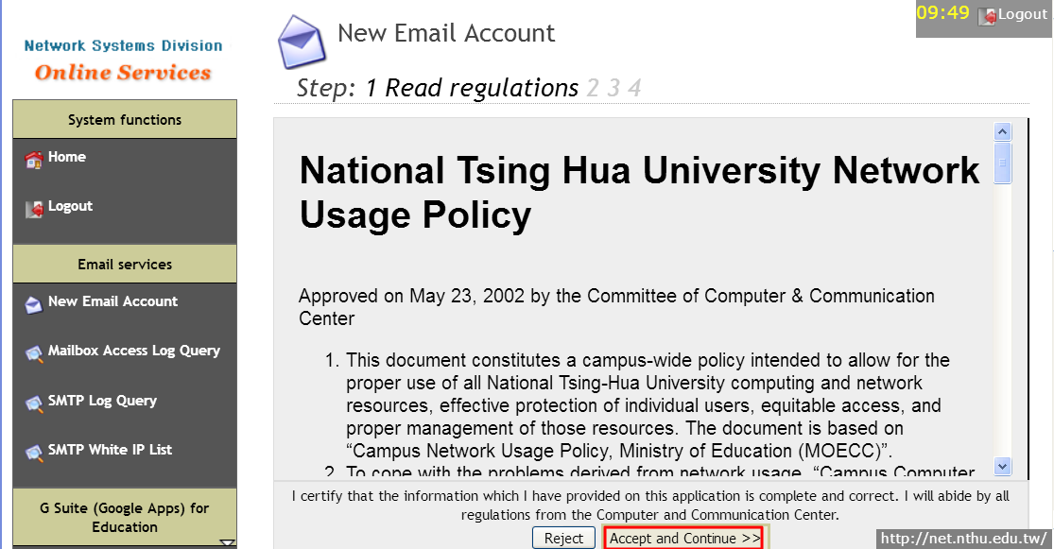
- Read 「Terms of Use for Email Accounts」，and then click option “Accept and Continue.”
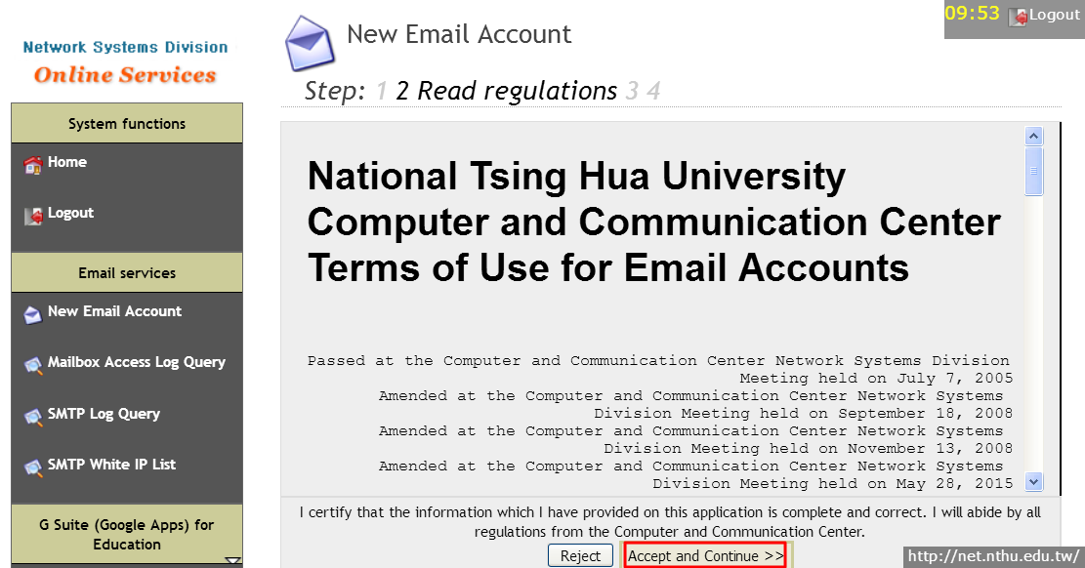
- Check the data and fill the fields of “NEW PASSWORD” and “CONFIRM” for setting your password.
  - NEVER send your password to anyone for anti-phishing.
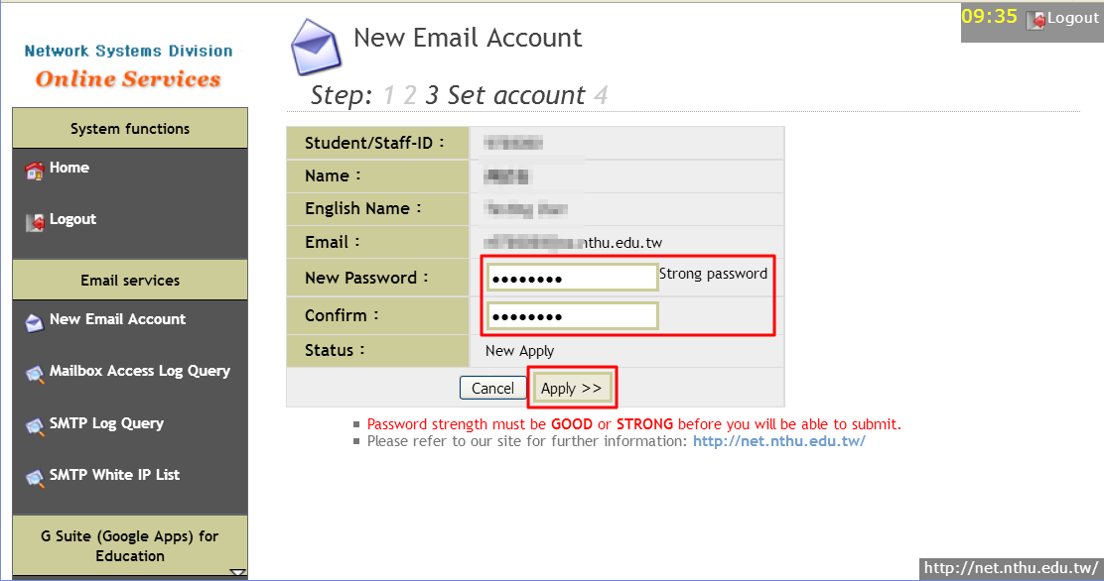
- Click “Apply” and then your new email account will work in 10 minutes if no error occurs.
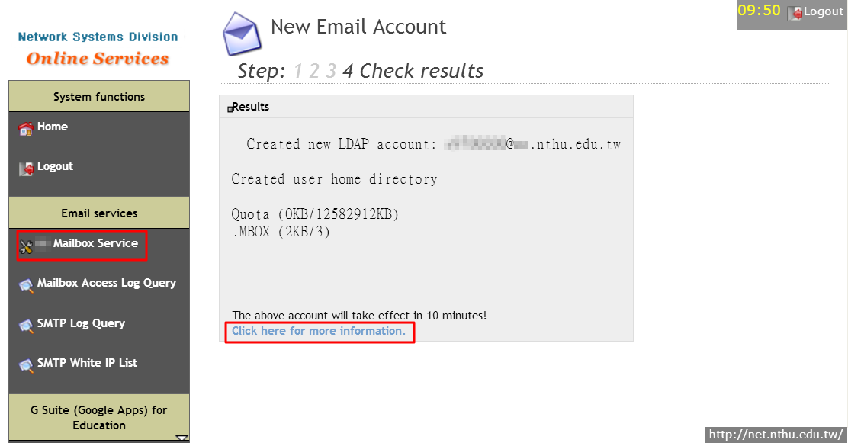

3. Designate email address for account notification
- Please refer to: https://net.nthu.edu.tw/netsys/en:mail:email2

4. Apply for mail alias for NTHU student mailbox
- Please refer to: https://net.nthu.edu.tw/netsys/en:mail:alias

