Wireless LAN Account Service Scope
The scope of campus WiFi accounts applied by the Center is divided into two sections：
- On-campus: Provides WiFi access when roaming through the campus
  - The Center has established and administered WiFi in public areas
Public areas include indoor spaces: Food Court、Wavelight Restaurant、Distance Classrooms、ZyXEL Auditorium、Feng Yun Building、Shui Mu Student Center、Student Dormitory Public Area…etc., and outdoor spaces:Food Court Outdoor Square、General Building II Pigeon Square、Student Union Outdoor Square、Cheng Kung Lakeside (Close to the side of Auditorium)、The Great Lawn… etc.
  - Departments have established and administered WiFi
The departments responsible for providing WiFi LAN services and accessing the Center authentication services include the library, Library、Department of Physics、Institute of Statistics、Institute of Computational and Modeling Science、Department of Mathematics、Department of Chemistry、Department of Power Mechanical Engineering、Department of Industrial Engineering & Engineering Management、Department of Chemical Engineering、Department of Materials Science and Engineering、Department of Biomedical Engineering and Environmental Sciences、Department of Engineering and System Science、Institute of Nuclear Engineering and Science、College of Humanities & Social Sciences、College of Life Science、Department of Electrical Engineering、Department of Computer Science、College of Technology Management、Tsing Hua College、Institute of Learning Sciences and Technologies… etc.
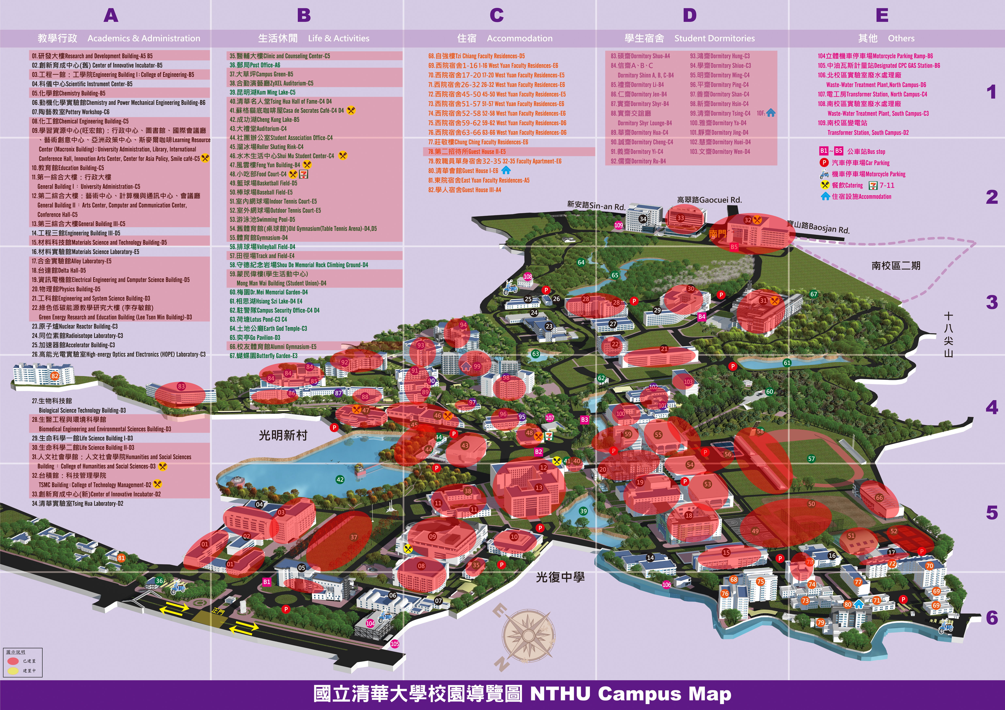Wireless LAN Account Service Scope
- Non-NTHU: Inter-school roaming
  - When using WiFi authentication for inter-school roaming, @wlan.nthu.edu.tw must be appended to your account. For information on inter-school roaming, please refer to the Ministry of Education's TANet's Taiwan Academic Network Roaming Center. For more information, please refer to Common WiFi problems “How do I access WiFi during inter-school roaming?”.
  - TWAREN SSL VPN Service：This services system requires a campus WiFi account for authentication (limited to NTHU faculty, staff, students, and short-term exchange students), and does not need to be accessed through a wireless network.

