How Do I Find Mail in the Mail Reporter?
- Log in to Mail Reporter。
- Select “Mailbox” at the left.
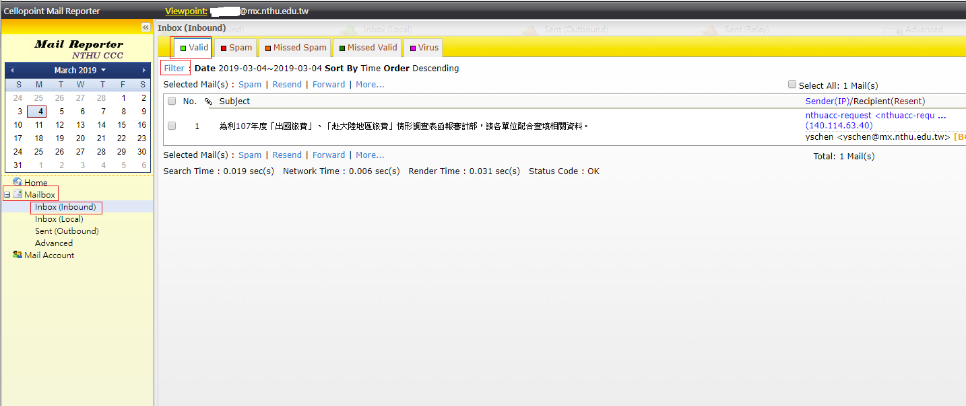
- By mail source - select the appropriate mail folder on the left:
  - Inbox( Inbound ): Means that the mail was sent to your email address.
  - Sent( Outbound ): Means that the mail was send from your email address.
- By mail category as determined by the system - select from the top:
  - Spam
  - Missed Spam：When the user tags “Valid” mail with “Spam”, the mail is moved here.
  - Valid
  - Missed Valid：When the user tags “Spam” mail with “Valid”, the mail is moved here.
  - Virus
- You can sort by date on the right or use “Filter” to further filter your mail (remember to click “Clear” after you have finished searching to reset the filter).


